Corporate One Co-Branded Resource

Essential Elements of Immediate Payments

Instructions

This article can be used to enhance your marketing and educational efforts regarding immediate payments and will help you communicate effectively with your target audience and showcase the value of the solution you offer your clients to connect to the RTP® network. The article can be copied and pasted for website content, newsletters, client emails, or key points and statistics can be posted to social media. Customization is welcome to align with your branding and contact information, but all content should be attributed to Corporate One (republished with permission).

Essential Elements of Immediate Payments

There has been a historic shift in how we live, work, and do business. Consumers and merchants across all ages, demographics, and industries have become more comfortable with a digital way of living and doing business, and this includes making digital payments. Fintech companies have led the charge with various solutions that deliver frictionless, transparent, and faster payment solutions that make paying easy. From ordering groceries to buying a car to settling a split dinner bill with friends, most experiences, goods, and transactions can be handled at the touch of a button. As the U.S. economy becomes increasingly digitized, consumers and businesses expect payments to be faster and immediate. As a result, the financial services industry is at a tipping point, with immediate payments in a prime position to be utilized as the primary digital payment solution of the future. Supported by two new payment rails (The Clearing House’s RTP® network, which launched in 2017, and the Federal Reserve’s FedNow® Service which launched in July 2023), immediate payments are here.

Immediate payments are already affecting consumers’ choice of financial institution, with one-third of consumers saying that access to immediate payments is a factor in their choice (PYMNTS.com, Dec. 2021). Additionally, 4 out of 5 Americans are interested in faster options to pay businesses for goods and services, and 61% of millennials and 59% of bridge millennials say they are highly interested in real-time payments. (PYMNTS.com, March 2023).

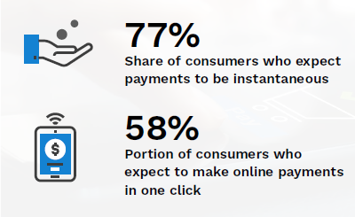

Source: PYMNTS.com Real-Time Payments Tracker, March 2023

As the rapid evolution of the payments ecosystem continues, it is important to recognize that it’s critical to begin adopting immediate payments as soon as possible. Understanding the essential elements of immediate payments—what they are and what they are not—will establish a solid foundation for your credit union to get started.

Identifying the transaction rails
In today’s payment world, transactions travel on separate rails. There’s the ACH rail, the debit/credit rail, and, most recently, The Clearing House’s RTP network, which has been live since 2017. The RTP network facilitates real-time payments and is not part of the other payment rails. The Federal Reserve launched its instant payment rail in July 2023 called the FedNow Service.

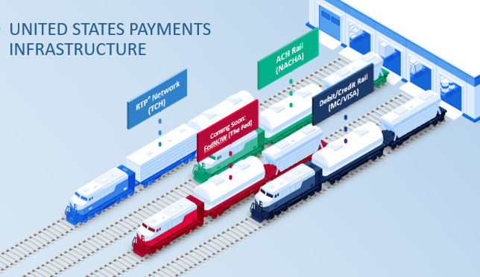
Like ACH, both rails support separate participant profiles for Receive Only, Send/Receive, and others. Many credit unions will find getting started with immediate payments as receive only is the best way to dip their toes into the water and enable their members to receive immediate payments. This is a smart strategy. It requires the lightest lift and the least risk. Like with ACH, credit unions will be able to evolve their profile over time and as it aligns with their payments strategy. Financial institutions must connect and be a participant of some level on either RTP or the FedNow Service or both to receive and/or send immediate payments. At this time, RTP and the FedNow Service will operate separately, and financial institutions will need to connect to, and at least receive transactions, on both rails to remain competitive.

Understanding faster payments vs. immediate payments
Though sometimes the terms “faster payments” and “real-time (and/or immediate/instant) payments” are used interchangeably, they really are two different things. Immediate payments stand apart from other legacy payment systems in five substantial ways:
- Immediate payments are certified. The payment authenticity is guaranteed.
- Immediate payments are final. They cannot be revoked or recalled once authorized by a sender and submitted. There is a Request for Return of Funds if immediate payment funds are sent in error, but this process occurs after settlement. In comparison, any returns on legacy payment systems can occur before funds are settled.
- Immediate payments are immediately available to the receiver. Senders and recipients also receive a status notification that funds were sent and are now available. Legacy payment systems clear in batches at varying times. Senders may not know for a few days if a transfer was successful and that funds are available to the receiver to use.
- Immediate payments are instantly settled. Legacy payments are settled by batch and at varying time intervals; with immediate payments, financial institutions settle funds instantly and individually.
- Immediate payments are confirmed. The payee and payor receive notifications of payment status. Legacy systems typically only notify the payer that the payment was sent.

Debunking misconceptions about immediate payments
Payments made through Zelle, PayPal or Venmo are not immediate payments. Zelle, PayPal and Venmo are the front-end applications that allow consumers to initiate a payment via an ACH, a debit, or the RTP network.
In addition, signing up for Zelle or your members using Venmo or PayPal does not give your credit union access to the RTP network. To transact payments on these rails, your credit union must be a participant and connect to the RTP network or FedNow Service to receive or send funds via a front-end application that sends via RTP or the FedNow Service. Just as you need to be an ODFI or RDFI on ACH to process ACH payments, you must be a participant on the RTP network or the FedNow Service to receive/send immediate payments.

Managing risk and fraud
Immediate payments relieve a lot of the settlement risk that financial institutions face today. Settlement risk is very real in existing payment forms, but by using a credit-push (good funds) model, which verifies money is available before it is sent, the immediate payments model eliminates transaction settlement risk on their network. Though this model doesn’t mitigate fraud, it does eliminate settlement risk. This means there is no risk for those financial institutions that start with receive only because the credit-push model verifies that the funds are good when sent. This is one of the reasons we recommend credit unions start their immediate payments journey as a “receive-only” participant. You can apply fraud/exposure mitigation tools that each new rail offers (such as setting send- and time-of-day limits) and extend existing fraud prevention methods to the rail you’re on as you migrate to a send profile.

Benefitting from immediate payments
Immediate payments offer numerous benefits to credit unions and the members they serve. Below are some examples of key benefits that often resonate most with financial institutions:

- Grow revenue by supporting a variety of use cases. Recent industry research reports that 40% of RTP users would willingly pay fees to get their payments in real-time, and 2 in 3 consumers say they would be more likely to continue doing business with firms that provide an immediate payment option. Further, approximately 50% of insurance, income and earning disbursement recipients would be willing to pay a fee to receive those payments instantly.
- Remain competitive by fulfilling members’ expectations and desire for immediate payments. Immediate payments are growing significantly while traditional check and cash continue to decline. In Q2 of 2023, RTP network transaction volume reached 58 million. Research says more than 1/3 of U.S. consumers cite access to immediate payments as a factor in choosing their financial institution. The RTP network currently reaches more than 65% of U.S. demand deposit accounts, which means these account holders are experiencing real-time payments for at least receive only.
- Address gaps in current payment methods through additional data, requests, security, and immediate availability. Immediate payments can facilitate a new request for payment (RfP), which allows a business or a consumer to send a request in the form of a message and allows the payor to authorize or deny the payment. Push, or credit, transactions enable payers to instruct their financial institution to send money from their accounts to recipients’ accounts, putting the payer in control of the timing of the release of their funds. The contextual data surrounding a payment has been missing from every previous payment system. Using the ISO2022 financial messaging methodology that creates standard, consistent payment messages across all business processes within the financial services industry, immediate payments offer the ability to attach information about the payment that doesn’t detach throughout the process, which is helpful during payment processing and reconciliation. Immediate payments facilitate real-time authorization, real-time posting, and real-time clearing and settlement.

Reimagining your business with real-world use cases
When most people think about immediate payments, the first use case that comes to mind is person-to-person payments. But as you can see with the following graphic from The Clearing House, ways you can use real-time payments are as diverse as the credit unions.
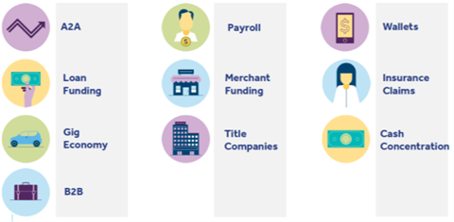
This chart is not an all-inclusive list of every type of use case, either.
The ways to use immediate payments are almost limitless. As each credit union experiments with and experiences immediate payments and analyzes its payment data, it will learn what use cases are most valuable to its specific credit union. And that’s the greatest benefit of this new payment option—the tremendous opportunity to enhance how credit unions serve members, streamline credit union business functions, and generate new products and revenue.

Are you interested in learning more about immediate payments? (Name of Org) has partnered with Corporate One to bring the benefits of immediate payments to (Name of Org) credit union clients through a simplified API that technically connects to the RTP network so your credit union can receive and send real-time payments without being limited in your payment messages and integration services. Click here (Link to Core's RTP Page) to learn how we can help make immediate payments a reality for your credit union.

This article was written by Corporate One Federal Credit Union. This article cannot be reproduced without the proper attribution to the original source.

