Announcement article/email: Please complete highlighted details below to customize for your organization.

[NAME OF ORG] is pleased to announce it has partnered with Corporate One Federal Credit Union, a certified third-party service provider (TPSP) for The Clearing House’s RTP® network to offer a seamless solution for you to connect to the RTP network so your credit union can begin receiving real-time payments for its members.
How it works
[NAME OF ORG] is utilizing a TPSP that has met certain standards set forth by The Clearing House to act on your behalf to receive real-time payment transactions. The solution offers an open payment platform that will connect your credit union to the network through a simplified API to receive real-time payments without being limited in your payment messages and integration services.
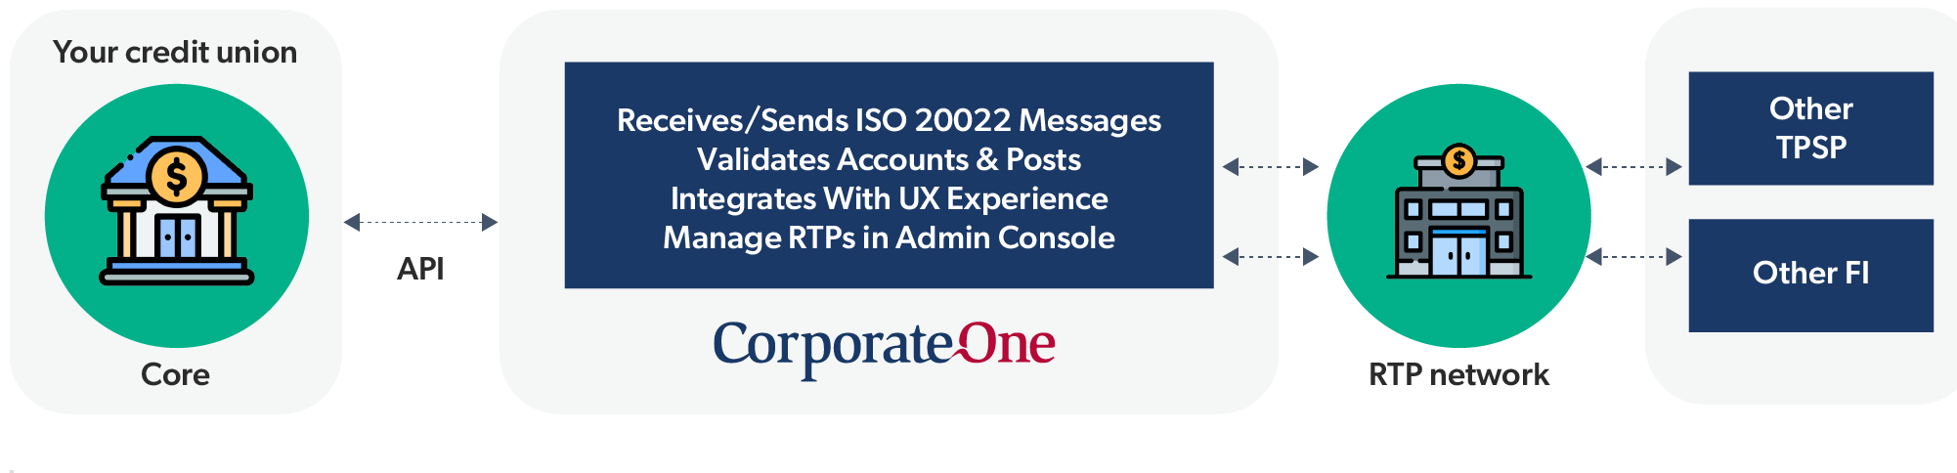Benefits for your credit union
- The service is turnkey, easy to implement, and offers accelerated onboarding to connect to the RTP network. The connection has already been built out for [NAME OF ORG’S] clients.
- The solution offers optimum flexibility to develop the experiences you want and future proofs payments modernization efforts by being able to support and extend to different payment networks in the future, such as the FedNow® Service.
- It includes a Funding Agent Service, which offers simplified 24/7/365 settlement and cash management of transactions, for streamlined onboarding to the RTP network. (You can also self-fund or select a provider of your choosing). This Funding Agent Service is complimentary for receive-only participants on the RTP network.
- The solution is certified for all profiles on the RTP network, including Receive only, Send and Receive, and Request for Payment (RfP).
Getting started
For more information, [get started instructions here]!

